The Self-Appraisal and Research Project

PG certificate course 2017
Student Name: Ervin Vastag
Hand in Date: 17/08/2017
(Word count: 3557)

According to Rogers (1959, cited in Rogers, Kirschenbaum and Henderson, 1989, p. 238), there are six necessary and sufficient conditions for the therapeutic change to take place. One of them, as Rogers stated, is the psychological contact between therapist and client. Listening skills are very important in counselling as listening is key to the effective communication and to make a psychological contact. Good listening skills are also important to build any effective relationship. In this last assignment I am going to explore the development of my listening skills and my ability to make a psychological connection with others. I am going to investigate this in the light of the theories related to the Rogers' person-centred approach.
I was always a very good listener and I can put myself in the other person's shoes (empathy). Yet in the past, I could not express my empathy. I did not know it is important (this is also one of the six conditions - the client needs to perceive that the therapist is empathic). During this course I have taught the importance of the communication of my feelings and how to make reflection in order to make connections with others. Furthermore, I realised, and this is my most recent and the most surprising discovery that communicating my weaknesses and even negative emotions can facilitate my connection with other people. Of course, these feelings need to be communicated in the right way. In the past, the lack of reflection and the lack of the expression of my own feelings had negative effects on my communication with others. For this reason I was more susceptible to rejections and judgements by others, which had negative effects on my self-esteem and on my self-concept. Besides, I am a very suggestible person and very sensitive on people's reaction. I easily take other people's perception and I often judge myself. To avoid stress I try to avoid places and situations where I experienced trauma and my self-esteem were undermined. For example, at work I wanted to please everyone and to prove that I am a good worker. I was usually focusing only on my work. I was not communicating much with people. As a result, I could not make friends at work easily; I was often excluded, stressed, tired and traumatised. However, recently, my people skills have gotten better. Also, I started to be self-employed, so I do not feel as vulnerable as before and I can do what I like. I went through some significant changes in recent years, so I am more open to people. Still, occasionally, when I am withdrawn, some people misinterpret my behaviour.
How we behave, think and feel, results from the interplay between two factors: the world outside ourselves (our social surroundings) and the world inside ourselves (our sense of self). Thorne (2003, pp. 31-32) suggested that our capacity to feel positive about ourselves depends on the quality and consistency of the positive regard shown to us by others. Where this is missing we are the victims of what Rogers described as conditions of worth. Rogers (1959, cited in Proctor 2002, pp. 84-85) hypothesised that when we encounter the conditions of worth (when we internalise the conditions of self-concept) we are getting removed from the organismic self (experiencing self) which goes against the person's actualising tendency. Rogers, Kirschenbaum and Henderson (1989, pp. 238-249) noted that this incongruence causes anxiety. In order to reduce this incongruence we can develop a self-defence mechanism, such as selective perception, distortion of the experience or denial to keep the perception of the experience consistent with the our self-structure and consistent with our conditions of worth.

It is essential that people who use counselling skills, they work on the lifelong process of discovering themselves and to become self-aware (Sally and Sally, 2001, p. 34). This course helped me to understand some of my internal processes, facilitated my self-development and improved my communication and the ability to make connections with others. My self-awareness increased. The peer feedbacks were very helpful for my self-exploration and for self-knowledge too. For example, some of my classmates indicated that I was rigid, especially at the beginning of the course. I was speaking consciously, but I was not showing emotions. In triads I was often focusing on the solutions instead of emotions. I often spoke in general, I was not going into details of my life and maybe I was hiding something. One person even mentioned that it was irritating her when I was showing off with my knowledge and I seemed arrogant with that (she referred to our previous course, but she also mentioned that she realised that this is not completely true). Also, some of them mentioned that I am often scared to say something, because I am worried how it is going to affect others. They also said that I was usually quiet and as a result, they could not know me better.
Besides, most of them considered that I was developing during the course and that my confidence has increased. I have noticed that when I am congruent and natural, it helps me to make a connection with others. I received many positive feedbacks as well from my peers. Many of them said that I have a gentle manner, I am calm, sensitive, helpful, deep thinker, intelligent, positive, spiritual, etc. The negative opinions did not stick on me as labels and they did not hurt my feelings, they made me think of them. This is good, because I can still tolerate critics and maybe I am not that vulnerable as I mentioned earlier. These feedbacks helped me to recognise the presence of the above mentioned protective mechanism and disharmony in myself. As I had understood some of my inner process, these feedbacks all made sense. Usually I have my own explanation (or subjective opinion) about people's opinion about me and why I am behaving in a way I do. I think that some of my behaviours can be linked to the above mentioned personality theories. The fact that I was not showing emotions and that I was wearing a facade was a way to maintain a self-structure. It was a shield that I used to hold to protect myself from eventual judgements and I was afraid of not being accepted. But actually this shield in itself can cause anxiety, which can negatively influence my relationship with others. Sanders (2011, p. 35) noted that the more discrepancy is there, the more the self-structure is rigid and trying to support this element within itself − element that is causing the problem in the first place. Healthy self-structure needs to be flexible, since the life unfolds in unexpected ways, so we must respond creatively.
In my opinion, at the beginning of the course, some of my classmates were also wearing a similar shield or a facade. Now, at the end of the course I feel sorry that I was unable to be more open and to show "this is me". Happily, this course was a safe place where I could develop. Also, it has taught me that being human and vulnerable is normal. My facade was a limitation for me that I could not take off within a short period of time. I felt anxious because of it. But, I managed to gradually release this anxiety. As I felt safe and accepted, gradually I managed to change. Probably my self-concept has changed during this course as well. Actually, if I link this to a theory, my rigid self concept and my facade could be interpreted as limitations for my actualising tendency. According to Sanders (2011, p. 38), the actualising tendency is an inborn capacity of human beings to grow and achieve their full potential. He noted that the actualising tendency can be harnessed, if the right conditions are present. People can solve their own psychological hurts. The right conditions are the core conditions of empathy, congruence and non-judgmental warmth. The helper (or perhaps significant others) provide these core conditions, enabling exploration of experiences, strengthening the self-concept and the tendency toward self-actualisation. This restores the control of our life to our 'organismic' self and facilitating a more fulfilling life.
During this course we had an opportunity to be helpers and to receive help as well. As we were mutually helping each other we have not just improved our listening skills, but also we experienced the 'healing' process on ourselves and on each other.
According to Sally and Sally, (2001, p. 34), the self is normally seen as having three parts: self-image, self-esteem and the ideal self. The self-image is the kind of person we think we are (could be positive or negative). It will include major social roles, such as our gender and age, together with what sort of person we think we are. They also suggested that the self-esteem refers to our self-evaluation, or sense of self-worth. It relates to the extent to which we approve ourselves. Certain characteristics or abilities have greater value in society than others, and our self-esteem reflects that. The ideas about our identity, self-image and self-esteem are the results from the messages we receive from others. These may be verbal, visual, physical and through observing the body language of others. They are from all significant others – including family, friends, employers, teachers, colleagues, the environment and the media. Our ideal self is the self we dream of being, a rich self, clever self, thin self etc. The greater the gap between our self-image and our ideal self, the lower our self-esteem will be.

Central to Rogers' personality theory is the idea of self-concept. Rogers (cited in Thorne, 2003, p. 35) believed that human beings to some extent possess the capacity and have the natural tendency to reorganise and reconstruct their self-concepts in order to make them more congruent with the totality of their experience. Rogers added that this capacity makes it possible for an individual to move away from a state of psychological maladjustment or disturbance towards a state of psychological adjustment. Rogers (1961, p. 258) stated that studies reported that primarily the self-concept is which changes during the therapy and not the ideal self.
It is interesting that different theorists use slightly different concepts to explain the organisation and concepts of the self. Even if we consider one psychological approach, it could be confusing and difficult to fully grasp the idea behind the personality theory. Some theorists describe congruence as an overlap between self-image and the ideal self (Sally and Sally, 2001, p. 34). While McLeod (2008) referred to the congruence when the ideal self is consistent with their experiences.

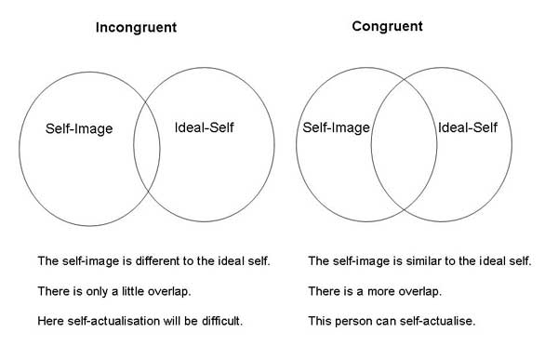

Figure 1. Congruence. Source: McLeod, 2008 (simplypsychology.org)
According to Thorne (2003, pp. 31-32), the internalisation of others opinions (conditions of worth), how should I feel and behave to be worthy of love and respect could lead to the sense of the personal worthlessness. Thorne added that it makes the person totally divorced from his or her organismic valuing process (OVP) with which the person was in contact before the consciousness of self emerged. Where such a discrepancy exists between the self as perceived and the actual experience of the total organism there is incongruence.

Eventually I managed to find the missing link to fully understand the personality theory (as overlaps of different selves were not very agreeable for me). Although the ideal-self and the organismic valuing process (OVP) may refer to the same or similar thing, the concept of ideal-self is less appealing for me. For me, the ideal-self is an artificial and unreal self, which is the idealised version of the self-concept. An imagined utopistic creation of the mind (as any other self), which is detached from the reality and it is not necessarily the reflection of the actual experience. But this idea about the ideal-self is just my perception and it could be interpreted in different ways.

Tolan's Skills in Person-Centred Counselling & Psychotherapy book gives me a more sensible explanation that stays close to my belief. Tolan (2012, p. 2) suggested, that all the experience we define are sensory input; all the information that comes through our five senses and "from internal or visceral feelings". This is referred as organismic experience. The experience is an organismic process that may depend on the current happenings (events) and past experiences. What we make out of the sensed information depends on the self-structure (Tolan, 2012, p. 14). Tolan (2012, p. 2) suggested, that according to the person-centred theory, individuals are always striving to integrate their organismic experience of the world with their self structure (also called self-concept, self-construction, self-identity, self-perspective). See Figure 2 for more details what is included in our OVP and in the self-concept.
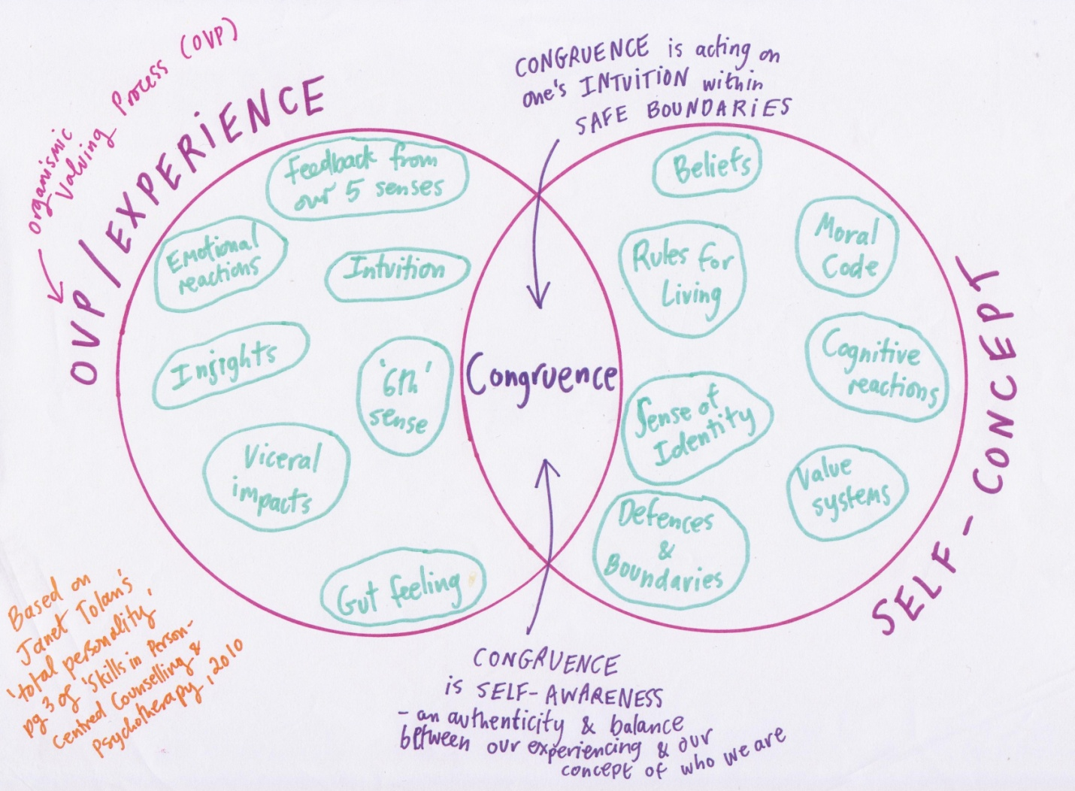

Figure 2. Lever (2012) Handout About Congruence Based on Tolan's (2010-12) Total Personality

According to Tolan (2012, pp. 43-44) the congruence is the part of ourselves that is open, flexible and non-defensive. In other words, it is the "you" in which there is no conflict between your self-structure and experiencing. This part of us is "aware"; congruence describes the element in our personality that is aware (see Figure 3). It is able to receive all our clients without judgement. Our perception is not fixed; our worldview is capable of being altered by what we hear from our clients. We are aware of our internal processes and we do not distort our reactions that are inconsistent with the idea how "a good counsellor" should be. If we make a judgement or if we are impatient, we can accept these feelings. This does not mean that we are telling all of our responses to the client, but we can have a choice whether to tell them or not. In person-centred counselling, we can communicate our understanding of the client's frame of reference (empathic communication) or we can talk from our congruent reference. To develop the ability to communicate our own experience, as stated by Tolan, we need to develop awareness of our thoughts and feelings in the relationship with the client and to learn when and how to communicate that awareness to the client.
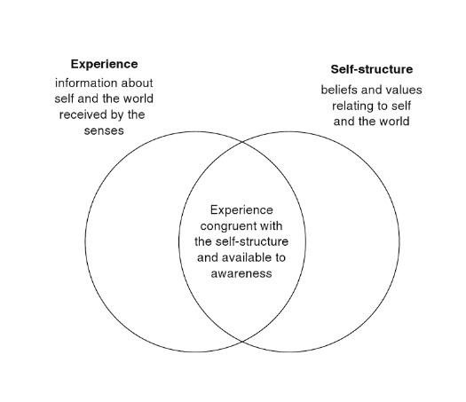
Figure 3. Congruance. Source: Tolan, 2012, p. 43
Mearns and Thorne (2008, pp. 139-141) suggest three guidelines when we can disclose our inner feelings and sensations:
- Is it in response to the client’s experiencing?
- Is it relevant to the immediate concerns of the client?
- Is the counsellor experiencing feelings that are persistent or particularly striking?
Also, it is worth to consider what is the motivation for sharing. Is the congruent sharing benefits the relationship or is it just about me?

Tolan (2012, p. 44) noted that the development of the self-awareness is a never-ending process. Counsellors in training have numerous opportunities for this (e.g. their own therapy, group work and supervision).
I grew up in an environment (childhood experience), where emotions were perceived as weaknesses. Therefore, in order to please others and to be accepted I learned not to show emotions. Now, I am relearning the ability to show emotions as I realised its importance in the everyday. Also, it helps to be real and congruent when I am helping others. As Sanders (2011, p. 96) suggested, the congruence or genuineness involves the helper being open to his or her own feelings without facade. The whole person of the helper must be brought into the therapy. If we leave our humanness behind, we will not be effective helpers.
I often need to remind myself, that even if I had a similar experience than others, they are never the same. For example, our response to stress is different. Sometimes, for a moment, it makes me laugh that some people stress about nothing, but then it comes me to cry, when I realise, that in that moment I lacked empathy and acceptance. I often think, how people can be stressed about “seemingly” unimportant things, but often I realise that I often catch myself doing the same. This moment of awareness gives a spin to my perception and consequently to my feelings, which could be really intense. At the end it feels like I was laughing at my own ignorance.
I already mentioned that at the beginning of the course I was often focusing more on the solutions than on emotions when I am working with people. It has somewhat changed as well. Although I still want to help people around me and to solve their problems, my perception has changed about helping. For example, my mother is a health care assistant and she often complains about her job. Earlier, I only wanted to help her to find her another job or to give her some advice. Now I focus on her feelings as well, not only on her problems. In addition, since I had similar jobs with similar issues, I could easily identify myself with her. I could get angry about the injustice she faces. Recently if she complains, I have tried to be more aware of my feelings, to connect with her and not to identify myself with her. Instead, I try to use my counselling skills.
In order to be relaxed and to feel better about myself, I am making an effort not to be bothered about other people's opinion (evaluation by others). So, I am not trying to please others to be accepted or approved. I am not trying to show myself perfect anymore and I try to be conscious about the fact that I do not need to prove or to achieve anything to show that I am valuable and lovable.
In the past 20 years I have changed several jobs and I have tried different lifestyles in different countries. I faced many difficulties in my life, such as war, family problems, unemployment and depression. Fortunately, I managed to recognise the importance of the self-improvement and awareness. Somehow, I managed to attract the opportunities into my life that I needed for self-healing. For example, it is very interesting that although I was attracted to psychotherapies in general (and I opposed the medical model of therapies), I did not have a clue about counselling before I started my introductory and theory course last year. I do not have any reasonable explanation how I ended up studying counselling. I was just attracted to it. It was only my intuition that led me here. Later I realised, this was one of my best decisions in my life. This course has helped me to get where I was striving to get as a person, emotionally to be in a better harmony, to be more open(hearted) and to continue in the process of my self-actualisation.
I remember how different situations and lifestyles influenced my self-perception and perception in my past. I think these experiences are valuable resources that help me to be open minded to people and help me to put myself in their shoes. I cannot really know what they went through and understand the way they think. However, I think, my relatively wide worldview gives me a better understanding of people’s perception and my empathy gives me the ability to get closer to that what they feel and what they think. As a result, sometimes, their stories can almost become my own personal experience that can make me richer.
In my opinion, I went through many positive changes in the past ten years. I have been studying energy healing, meditation, self-development and counselling. They all had a positive effect on my life. My counselling courses have helped me to be more open and allow myself to feel more and to be aware of it. I have better reactions from people because I am more able to communicate them in a human and natural way. Recently I made a friend simply by not being too formal in the communication with her. We even managed to talk through some of my issues and about my process of change. We agreed that “there's no point being the person you're not. We are more beautiful when we are real and not trying to show off just to impress and to be loved by others”.
Beside self-development, by studying counselling I got a valuable tool for helping others. I enjoyed this course and I feel that I am ready to get the certificate and I deserve it too. I really liked the balance of the course. It was good that we discussed some theories, but we had practised as well. I liked the community time as well, when we managed to discuss our issues and we could freely express ourselves. This freedom let the atmosphere unique and spiritual. I am planning to continue my counselling studies in order to become a professional counsellor. But, I do not feel I can do it now. I do not know why, but I need some time to get ready (perhaps emotionally) for this step. Besides, I would like to open a healing centre, where I can use my counselling skills (as well). In addition, perhaps I can offer a counselling service in the future too. I want to continue my journey. Not only professionally, but with my self-development too. I need to continue working on some of my above mentioned issues (to be open, to communicate my feelings, accepting myself, etc.).
“You must be the change you want to see in the world.” Mahatma Gandhi

References
Lever, K. (2017) Handout About Congruence Based on Tolan, J. (2010-12) Total Personality

McLeod, S. A. (2008) Self Concept Available at: www.simplypsychology.org/self-concept.html (Accessed: 21 July 2017)

Proctor, G. (2002) The Dynamics of Power in Counselling and Psychotherapy: Ethics, Politics and Practice, Ross-on-Wye:PCCS Books
Rogers, C. (1961) On Becoming a Person A Therapist’s View of Psychotherapy, Boston: Houghton Mifflin

Rogers, C., Kirschenbaum, H. & Henderson, V. (1989) "Theory and Research: Chapter 17: A Theory of Therapy" in The Carl Rogers Reader, ed. by Kirschenbaum, H. & Henderson, V. London: Constable

Sally, A. & Sally, R. (2001) Counselling Skills in Context, Abingdon: Hodder & Stoughton
Sanders, P. (2011) First Steps in Counselling, PCCS Books 2011

Thorne, B. (2003) Carl Rogers, London: Sage, 2nd edition

Tolan, J. (2012) Skills in Person-Centred Counselling & Psychotherapy, London: Sage

